**Product Roadmap for Compliance Management System (CLM Tool)**

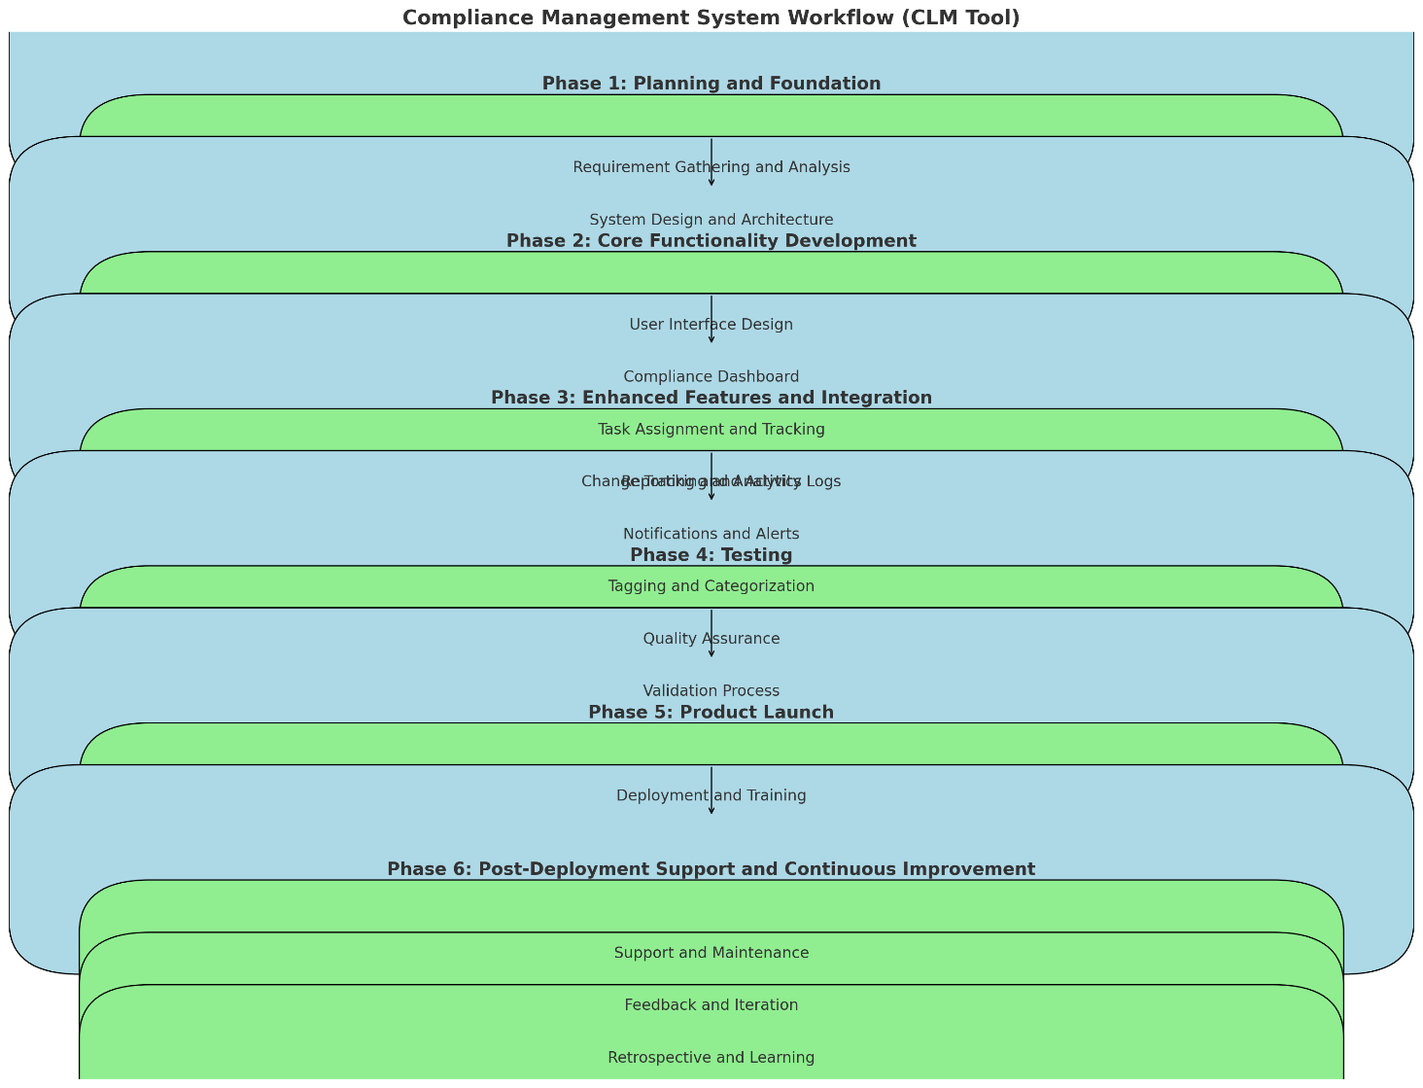

**Phase 1: Planning and Foundation**

1. **Requirement Gathering and Analysis: (Tools-** ProductBoard, Jira, Confluence, Microsoft Excel/Google Sheets, Lucidchart, Trello, Miro)
   * Conduct workshops with legal teams, compliance owners, and stakeholders to understand current pain points and desired features.
   * Define compliance types (critical, good to have, optional) based on regulatory requirements and organizational priorities.
2. **System Design and Architecture:** (**Tools-** Depends on the current organizational requirement)
   * Design a scalable and robust architecture for the CLM tool, ensuring data security, compliance with data privacy regulations, and integration capabilities with existing systems (if any).
   * Choose appropriate technology stack and framework for development.

**Phase 2: Core Functionality Development**

1. **User Interface Design: (Tools-** Miro/ Figma/ Adobe XD**)**
   * Create intuitive UI/UX designs with a focus on simplicity and ease of use.
   * Ensure responsiveness across different devices and browsers.
2. **Compliance Dashboard:**
   * Develop real-time dashboards for monitoring compliance status, deadlines, and overall compliance health.
   * Include graphical representations (charts, graphs) for quick insights into compliance metrics.

1. **Task Assignment and Tracking: (Tools-** Jira/ Confluence)
   * Implement features for creating, assigning, and tracking compliance tasks.
   * Allow task delegation, setting priorities, due dates, and dependencies.
2. **Change Tracking and Activity Logs: (Tools-** Jira/ Confluence)
   * Enable version control and audit trails to track changes made to compliance tasks and documents.
   * Maintain detailed activity logs for transparency and accountability.

**Phase 3: Enhanced Features and Integration**

1. **Reporting and Analytics: (Tools-** Power BI/ Tableau/ Google Analytics)
   * Develop customizable reporting templates and analytics tools to generate compliance reports.
   * Include filters and export options for generating compliance snapshots and detailed reports as required.
2. **Notifications and Alerts:** 
   * Integrate notification systems (email, in-app notifications) for reminders, upcoming deadlines, task updates, and compliance status changes.
   * Allow users to set personalized notification preferences.
3. **Tagging and Categorization: (Tools- ProductBoard)**
   * Implement tagging functionalities to categorize compliances based on type (critical, good to have, optional) and regulatory requirements.
   * Enable filtering and searching based on tags for quick access to relevant compliance tasks.

**Phase 4: Testing**

1. **Quality Assurance:**
   * Conduct rigorous testing (unit testing, integration testing, user acceptance testing) to ensure the CLM tool meets functional and performance requirements.
   * Address any usability issues or bugs identified during testing phases.
2. **Validation Process:**
   * Select a subset of representative beta testers for quick feedback collection.
   * Distribute beta versions of the product with a focus on critical use cases.
   * Analyze high-impact issues and prioritize immediate fixes or adjustments.

**Phase 5: Product Launch**

1. **Deployment and Training: (Tools- AWS/ Azure/ GCP)**
   * Launch the CLM tool in a phased approach or as per organizational readiness.
   * Provide training sessions and user documentation to ensure all stakeholders can effectively use the tool with minimal training.

**Phase 6: Post-Deployment Support and Continuous Improvement (Tools- SalesForce/ ProductBoard)**

1. **Support and Maintenance: (Tools- SalesForce)**
   * Establish a support mechanism to address user queries, issues, and enhancement requests post-deployment.
   * Regularly update the CLM tool to incorporate new compliance regulations, security patches, and user feedback.
2. **Feedback and Iteration: (Tools- SalesForce/ ProductBoard)**
   * Gather feedback from users and stakeholders to identify areas for improvement.
   * Plan iterative releases to introduce new features, enhance existing functionalities, and improve user experience based on feedback and market trends.
3. **Retrospective and Learning: (Tools- Miro/ Microsoft Tools/ Sketch)**
   * Reflect on the recent iteration/project phase to identify strengths and areas for improvement.
   * Foster continuous improvement, enhance team collaboration, and optimize project processes.

**Go-to-Market (GTM) Activities:**

* + Develop Marketing Collateral
  + Pricing Strategy and Packaging Options
  + Create Sales Enablement Materials
  + Plan Promotional Activities
  + Execute Marketing Campaigns
  + Monitor and Adjust GTM Strategies

**Execution Illustration: Specific Modules/Features**

* **Dashboard Module:** Implement using modern web frameworks (e.g., React.js) for real-time data updates and interactive visualizations.
* **Task Management Module:** Use Agile development methodologies to iteratively build and test task assignment, tracking, and notification features.
* **Reporting Module:** Develop using data visualization libraries (e.g., D3.js) for customizable reports and analytics dashboards.
* **Security and Compliance:** Ensure adherence to GDPR, CCPA, or relevant data protection regulations throughout development and deployment phases.